PROJECT NO. 1

**Information Gathering and Exploitation**

**Task 1:** Take some random websites using Google hacking database and enter into their admin panel using SQL Injections (Manual and using a tool called burp suite)  
**Task 2:**Show some live cameras using Google hacking database.

TASK 1:

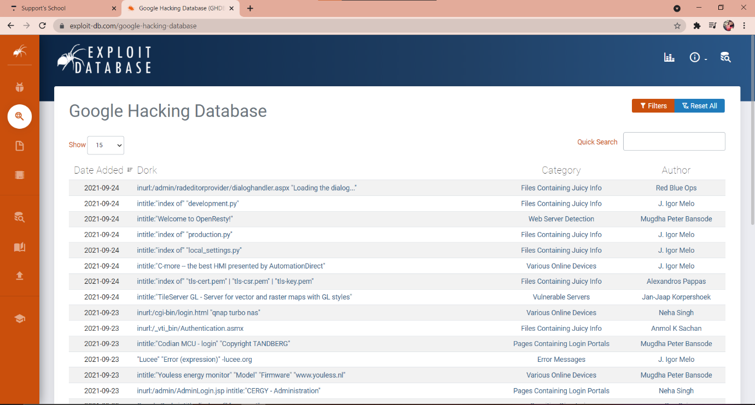To exploit admin pages search for google hacking databases in google.

Copy the syntaxes and paste in google. Other than .edu and .gov open random websites and try sql injections.

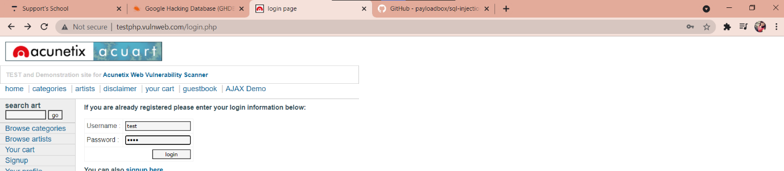Try different payloads “1’or’1’=’1’ ” ; “1-false”etc same in user name and password.

Try logging in

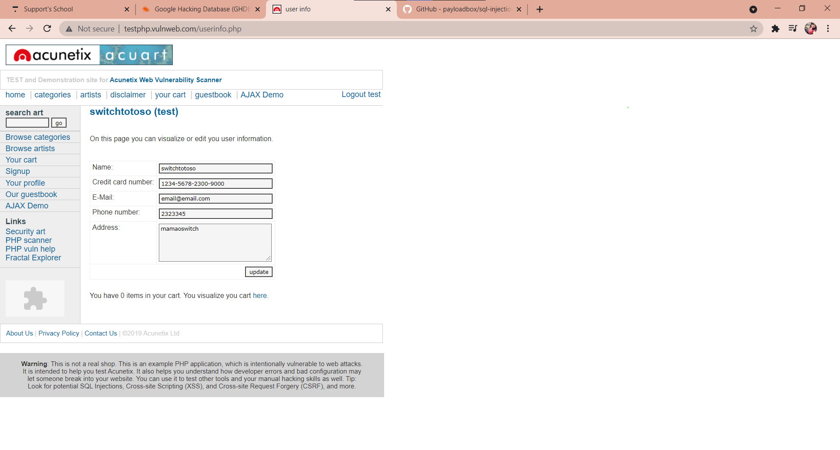

Website 2:

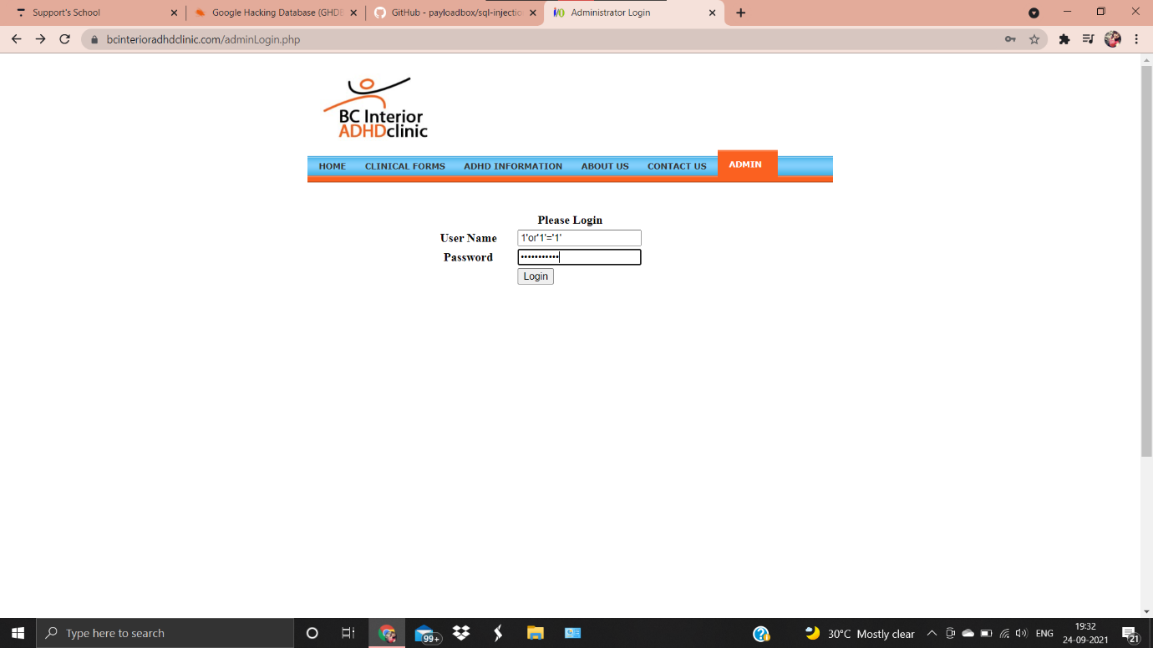

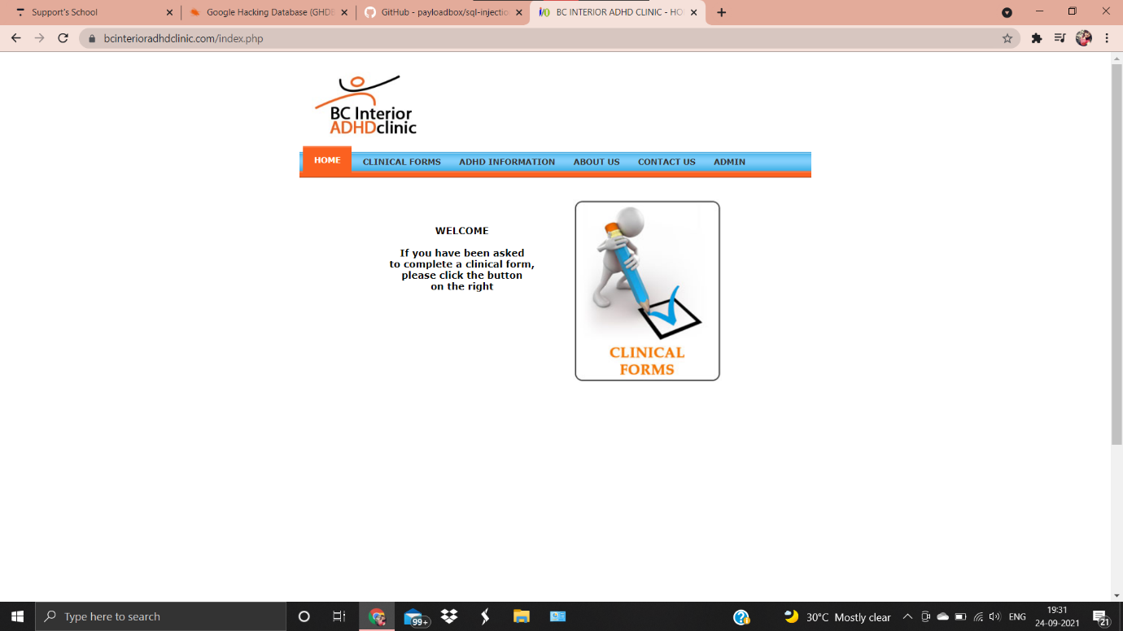

Open burp suite

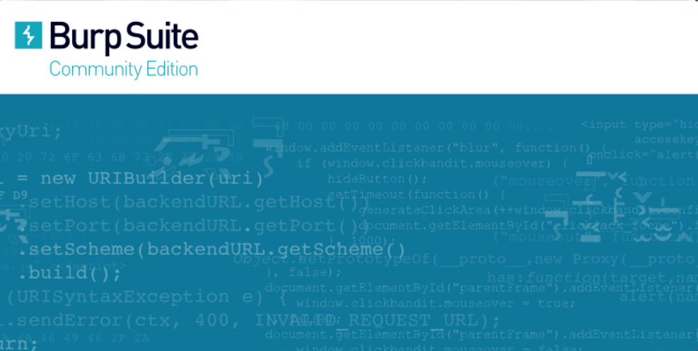

Start burp suite

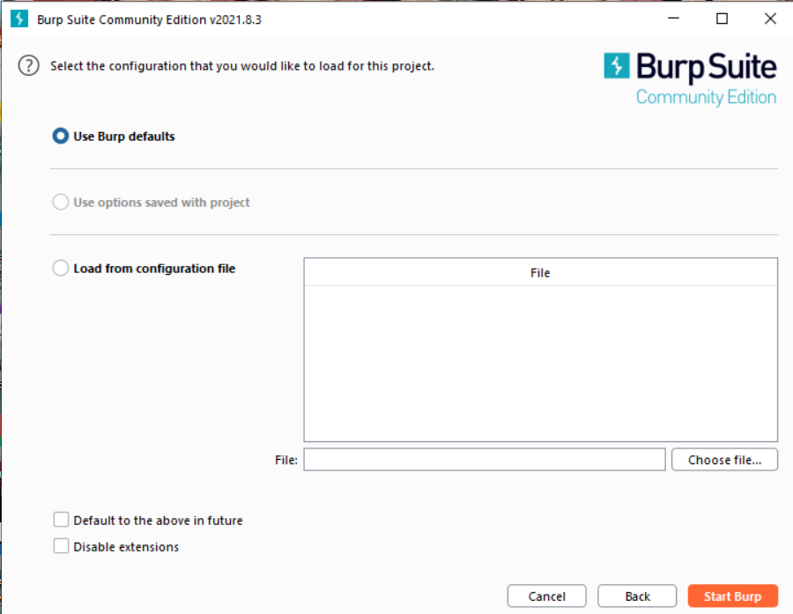

The dashboard of burp will appear on the screen

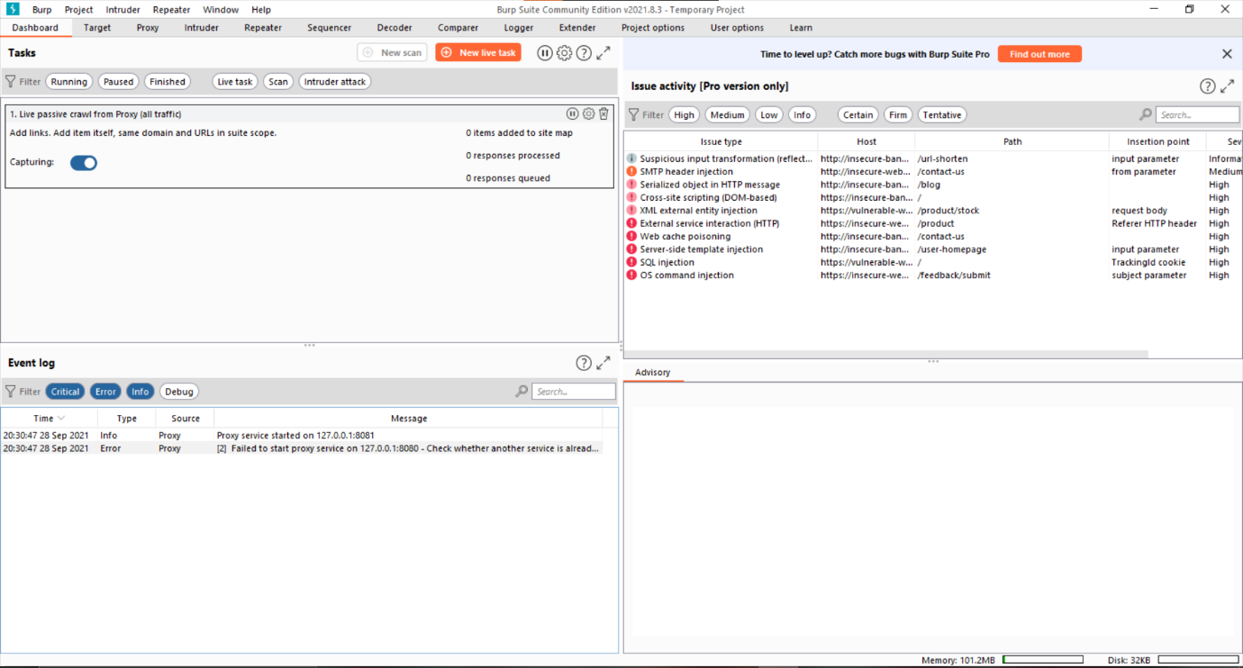

Go to proxy server and turn on the intercept to capture the packets and then turn off

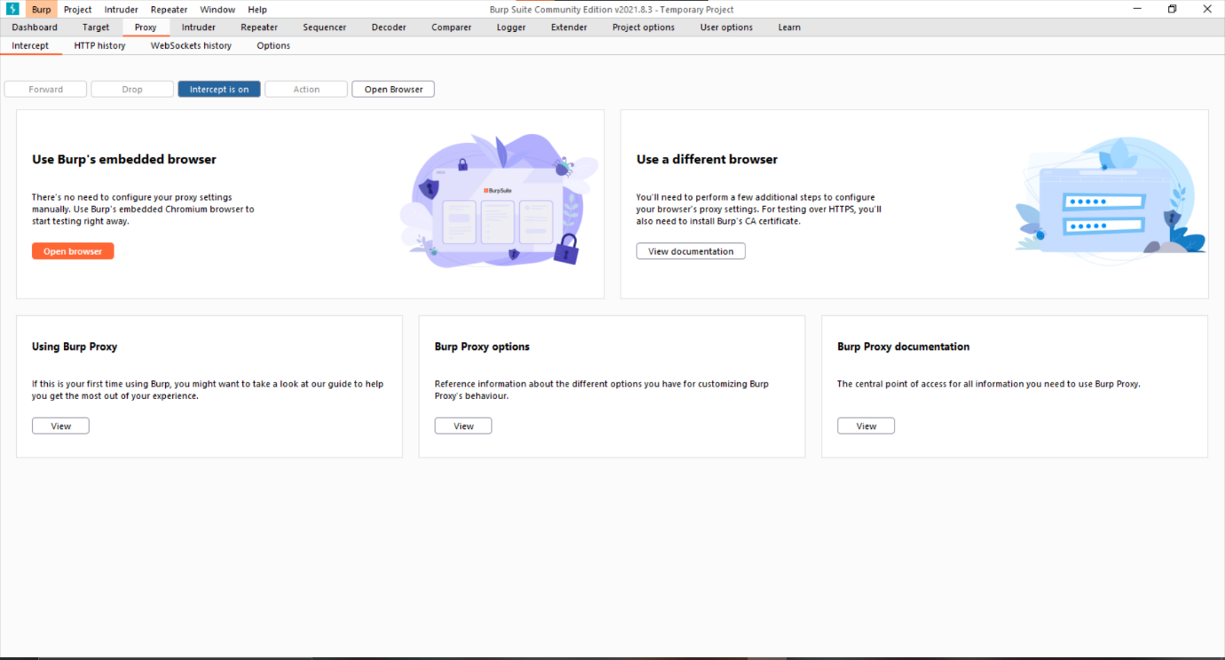

TASK 2:

To show some live cameras using Google hacking database copy the syntax.

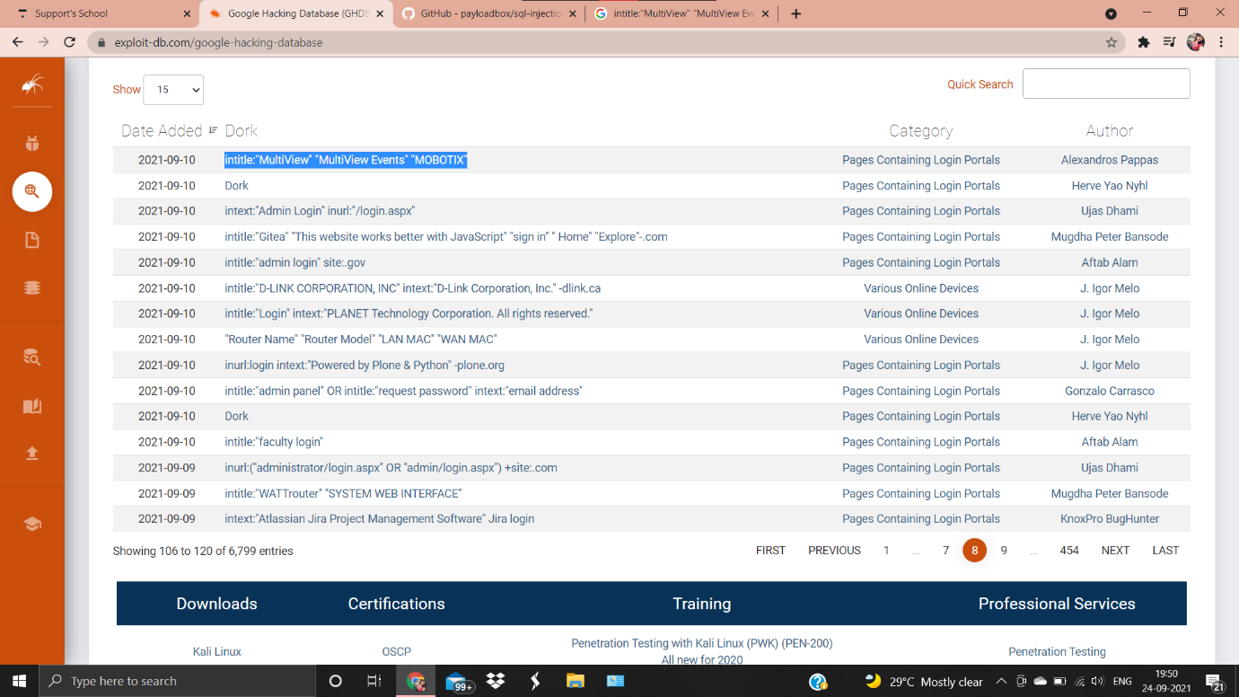

The syntax which contains webcam copy and paste on google.

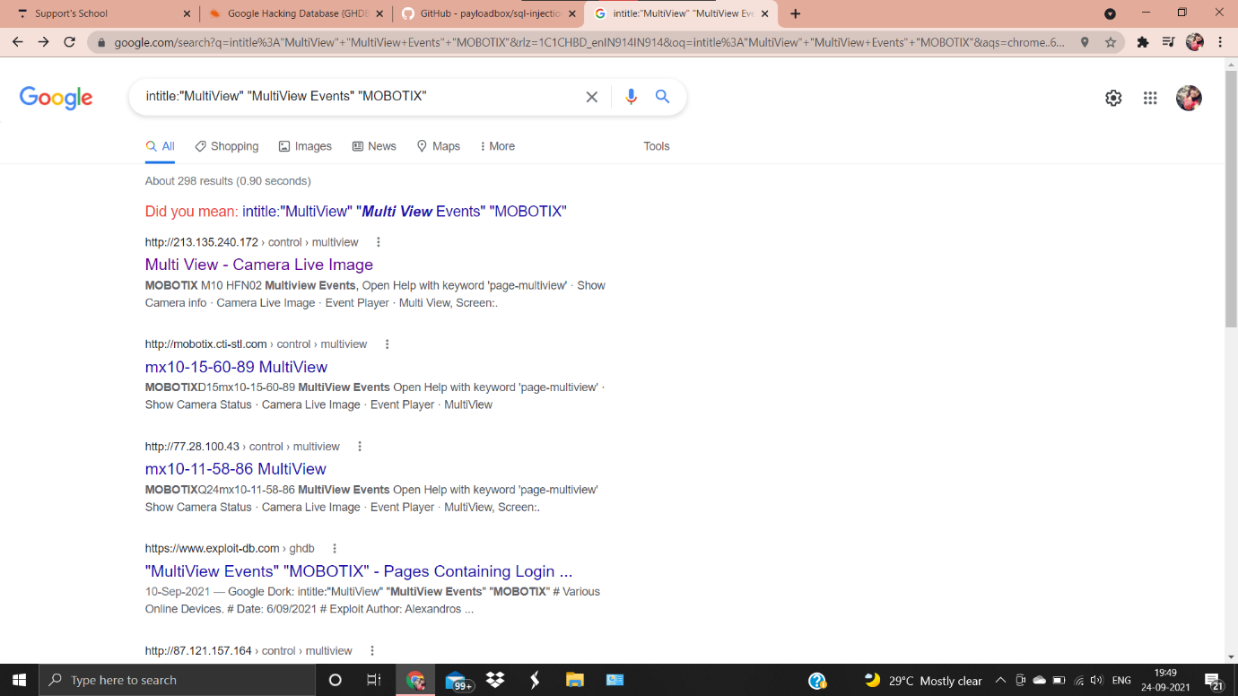

Live camera 1:

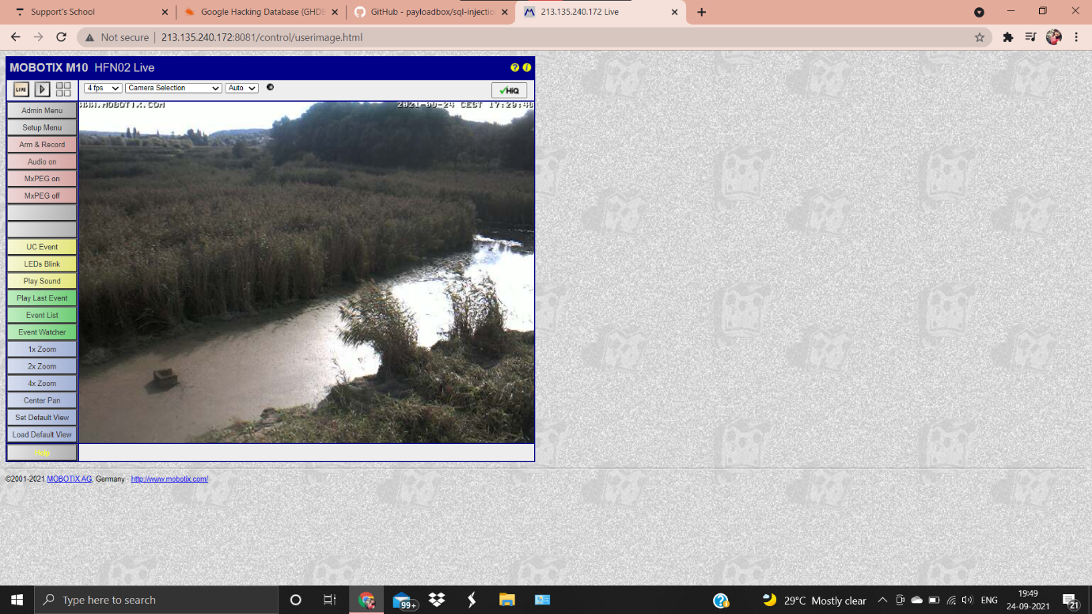

Live camera 2:

